DoS - Denial of Service
Cyber-attack with intent to cause temporary or indefinite disruption of service


DDoS - Distributed Denial of Service
DoS attack that is originating from multiple servers
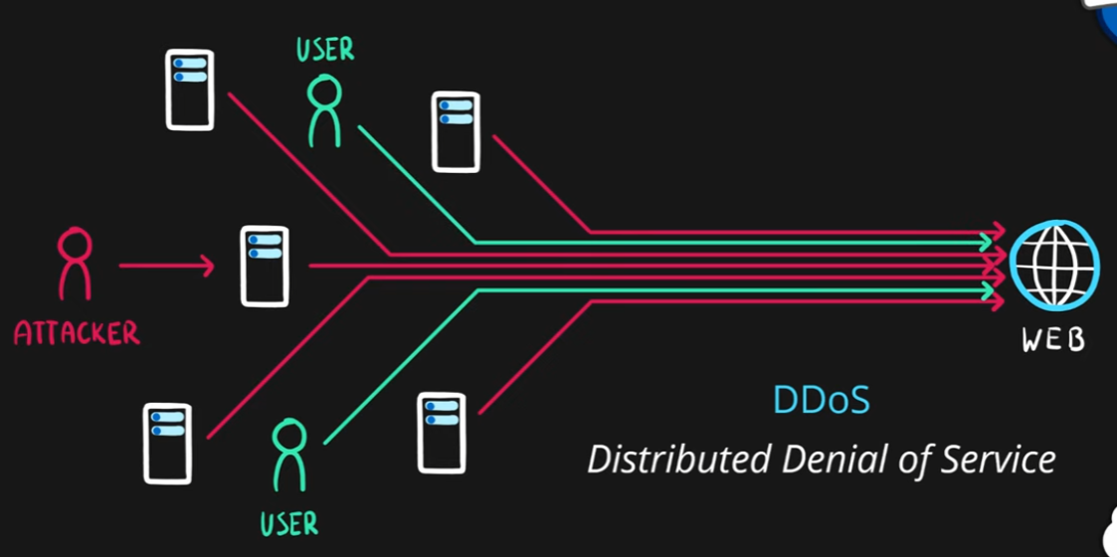

Azure DDoS Protection
- DDoS protection service in Azure
- Designed to
  - Detect malicious traffic and block it while allowing legitimate users to connect
  - Prevent additional costs for auto-scaling environments
- Two tiers
  - Basic – automatically enabled for Azure platform
  - Standard – additional mitigation & monitoring capabilities for Azure Virtual Network resources
- Standard tier uses machine learning to analyze traffic patterns for better accuracy
